

Human Biology ATAR Unit 2

Task 8 Validation – DNA Solutions

Weight 10%

1. a) Explain what is meant by gene expression. (2 marks)  
   Mechanism that produces a protein from a gene i.e. protein synthesis (1)   
   and turn genes on or off / expressing the gene or silencing the gene (1)

b) How does gene expression relate to a cell in a salivary gland? (2 marks)  
Salivary gland cell is **specialised** to produce amylase / digestive enzyme (1)  
so amylase gene is turned on and most other genes are turned off (1)

1. Explain how the epigenome allows the first section of DNA to be transcribed but not the second. (3 marks)

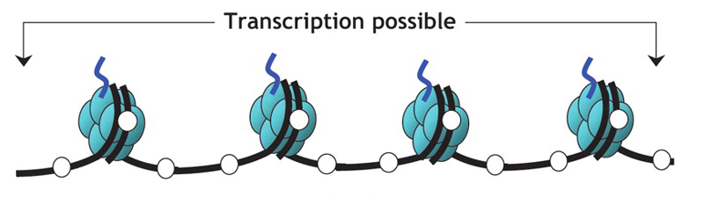

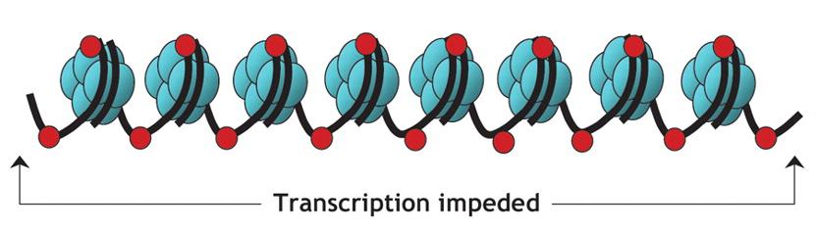  
In the first diagram DNA is less coiled / unwound / more exposed (1)

Due to no methyl markers / unmethylated cytosines / no DNA methylation (1)

Acetyl group added to histones / acetylated histones (1)

**NEED** Genes are expressed / swtiched on (1)

1. Seventeen-year-old identical twins, Adam and Michael, are both considered to be tall individuals: Adam is 192 cm and Michael is 188 cm. Explain how the different heights of Adam and Michael can be attributed to epigenetics. (3 marks)  
   Adam and Michael have exact same genotype / genes for height (1)  
   (At least one) environmental factor (diet/health) has differed between Adam and Michael during development (1)  
   More of Adam’s genes for height are expressed / turned on [or vice versa] (1)
2. Using an example explain how the discovery of epigenetic factors has transformed the way we think about characteristics that can be passed from one generation to another. (4 marks)